**Ideation Phase**

**Define the Problem Statements**

|  |  |
| --- | --- |
| Date | 16 June 2025 |
| Team ID | LTVIP2025TMID55293 |
| Project Name | HOUSE RENT APP USING MERN |
| Maximum Marks | 2 Marks |

**Customer Problem Statement Template:**

Create a problem statement to understand your customer's point of view. The Customer Problem Statement template helps you focus on what matters to create experiences people will love.

A well-articulated customer problem statement allows you and your team to find the ideal solution for the challenges your customers face. Throughout the process, you’ll also be able to empathize with your customers, which helps you better understand how they perceive your product or service.

**Example:**

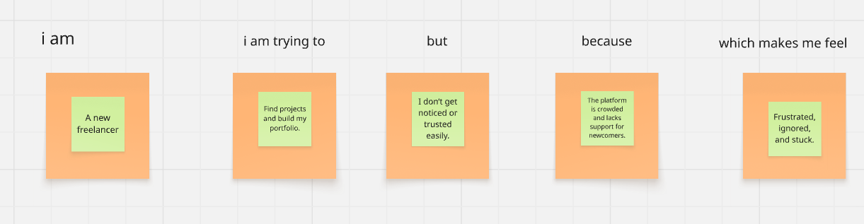

|  |  |  |  |  |  |
| --- | --- | --- | --- | --- | --- |
| **Problem Statement (PS)** | **I am (Customer)** | **I’m trying to** | **But** | **Because** | **Which makes me feel** |
| **PS-1** | A skilled freelancer, eager to find work. | Get freelance projects and grow my career. | I don’t get selected or noticed easily. | The platform is crowded and lacks tools for new freelancers. | Frustrated and demotivated. |
| **PS-2** | An admin managing freelancer and client activity. | Keep the platform secure and workflows smooth. | It’s hard to track quality and manage issues manually. | There's no central dashboard for oversight and control. | Drained and constantly under pressure. |